Studying methods:

- Active recall - self questioning, flash cards, practice questions/ exam questions

- Spaced repetition - habitual repetition of active recall to improve memory retention
- Feynman Technique - learning by defragmentation and blurting

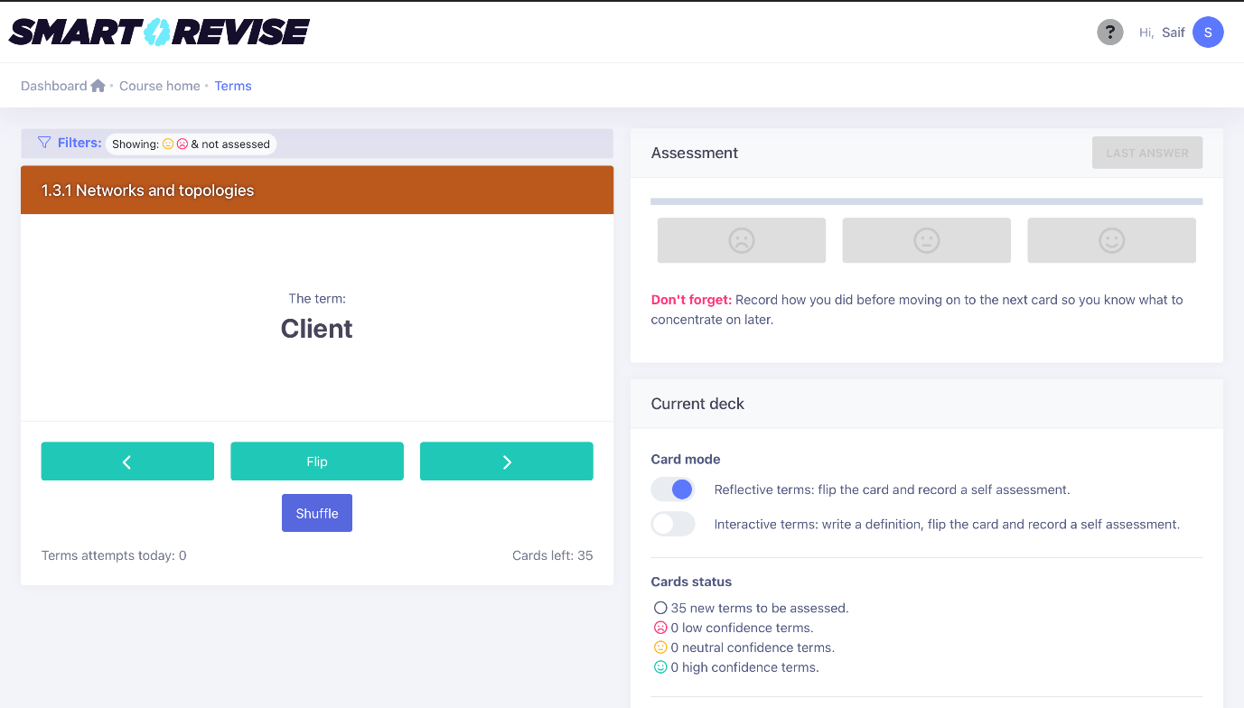

we can improve upon the smart revise flash cards system- after a certain amount of flash card questions, practice papers about the definitions will be asked and instead of 3 reactions
there will be 6 to indicate understanding.


